First activate virtual env
Then install :
pip install pytest httpx

create main.py
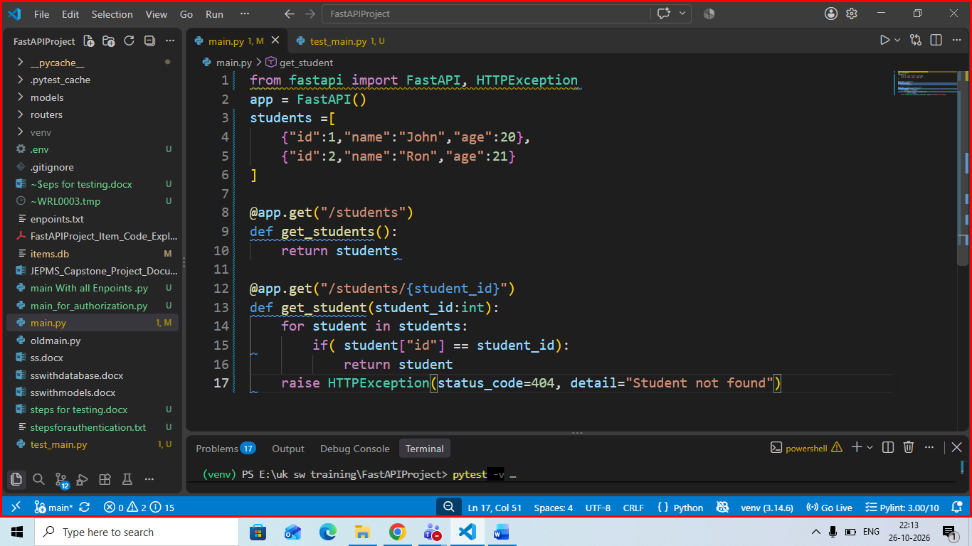
for createing automated test create file with name test_main.py
in test_main.py
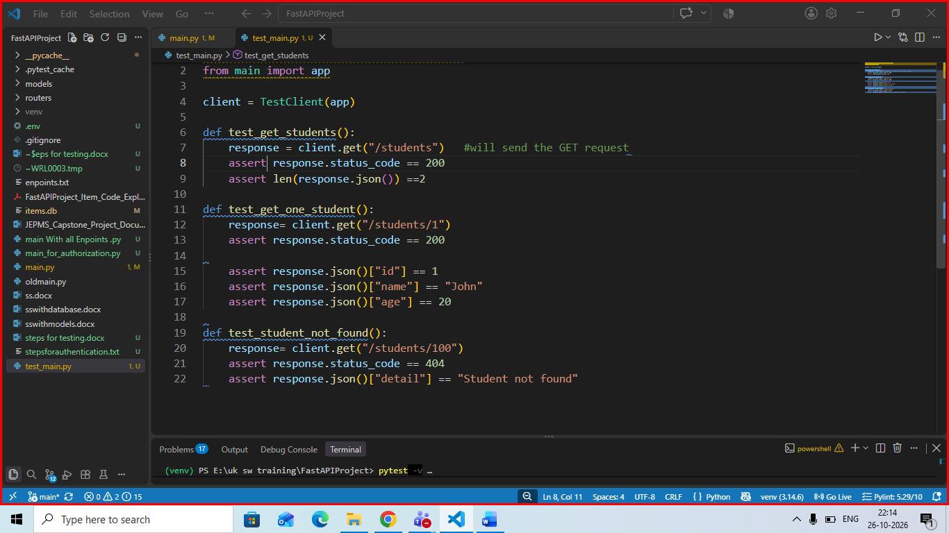

run test using command pytest -v

